**ReportITT Web Application**

**Software Design Document**

**Prepared by Dylan Avatar Maharaj**

**The University of the West Indies**

**12/02/2022**

Table of Contents

1 Introduction 5

1.1 Purpose 5

1.2 Scope 5

1.3 Overview 6

2 System Overview 7

2.1 Web Application 7

2.2 Laravel Backend and MariaDB Database 8

3 System Architecture Design 9

3.1 Architectural Design 9

3.1.1 Web Browser Interface 10

3.1.2 Login and Signup 10

3.1.3 Home 11

3.1.4 My Reports 11

3.1.5 Statistics 11

3.1.6 My Profile 11

3.2 Decomposition Description 12

3.2.1 Web Browser Interface 12

3.2.2 Registration and Login Module 12

3.2.3 Home 13

3.2.4 My Reports 13

3.2.5 Reporting System 14

3.2.6 Statistics 14

4 Data Design 16

4.1 Data Description 16

4.2 Data Model 17

4.3 Data Dictionary 19

5 Component Design 25

5.1 Register/Login Module 25

5.2 Reporting System Module 26

5.3 My Profile 27

List of Figures

Figure 1 The System Architecture 9

Figure 2 The Login Module Deccomposition 12

Figure 3 The Home Module Decomposition 13

Figure 4 My Reports Module (General User) Decomposition 13

Figure 5 My Reports Module (SP User) Decomposition 14

Figure 6 Statistics Module Decomposition 15

Figure 7 The Entity-Relation Diagram 17

Figure 8 Component Design of the Register/Login Module 25

Figure 9 The Reporting System Module-Process Breakdown 27

Figure 10 Process Diagram for the My Profile Page 28

List of Tables

Table 1 The Organisation Assignments based on the Email Domains 10

Table 2 Metrics in the Statistics Module 15

Table 3 Entity and Purpose 16

Table 4 Data Dictionary for the Entities 19

# Introduction

## Purpose

This document describes the architecture and system design of the “ReportITT Web Application”. This document is aimed at project supervisors and examiners for ECNG 3020 as well as other developers.

## Scope

The ReportITT Web Application is an application built using the Laravel Framework. It supports devices with compatible web browsers.  The application is designed to achieve different objectives based on the user’s organisation ID. The intended organisation assignment is shown in Table 1.

For General users, the product functions are as follows:

* Connect to the online MariaDB Database.
* Allow the user to log in or sign up.
* Allow for OTP verification on sign up.
* Assign roles to users based on their email domain.
* Allow users to create a report.
* Accept user input such as location, text, and images.
* Log the time a user creates a report.
* Load all reports onto the map GUI.
* Allow users to view reports.
* Allow users to upvote reports.
* Show the status of the report made(Acknowledged, In-Progress, Resolved).
* Produce email notifications when fault report status has been changed.
* Allow users to tag reports as false.

For TTEC Admin, WASA Admin and TATT Admin users, the product functions are as follows:

* Connect to the online MariaDB Database.
* Allow the user to log in or sign up.
* Assign roles to users based on their email domain.
* Restrict user action based on type of report. For example, if the report has to do with a TTEC fault, only the TTEC Admin can update the status of it.
* Allow users to view reports on the map.
* Allow users to change and update the status of reports.
* Allow users to delete reports from the map.
* Produce email notifications when a fault is reported to their utility company. For example, if a report is made on a broken electrical pole, only the TTEC Admin users would receive notifications.
* Allow users to produce statistical reports of faults reported to their utility company.

## Overview

This document consists of the System Overview, System Architecture Design, Data Design, Component Design and Human Interface Design. The System Overview chapter shows an outline of the system. The System Architecture Design chapter explores the design of the system through a series of block diagrams illustrating the subsystems. The Data Design chapter shows the database used and explains the data structure used. The Component Design chapter describes the subsystems previously explored in the System Architecture Design chapter through the use of process diagrams. Finally, the Human Interface Design illustrates through wireframes, the layout of each screen in the web application.

# System Overview

From the project objectives, the main purpose of the application is to produce a utility reporting system that would allow for timestamp, text, image and GPS tagging of where a fault has occurred.

The system consists of two major subsystem blocks:

1. A web application
2. Laravel backend with a MariaDB database.

## Web Application

ReportITT is the name of the web application. The application was developed targeting the popular web browsers such as Google Chrome, Modzilla Firefox, Internet Explorer and Safari.

Depending on the device, the application can make use of the GPS and Camera hardware to capture user location and image data. For PC users, if location permissions are allowed, the application would use the Geolocation API for determining user location. For all devices, the user can manually change the location marker on the GUI to better reflect the location of the reported issue. All other data would be entered using the keyboard of the device.

The application would also load existing reports from the MariaDB Database and display them as markers on the map GUI. Additionally, the general users can view, upvote, and tag the faults as false.

The application is designed for multi-tenancy amongst several service providers (referred to as organisations in this document): TSTT, TTEC, and WASA. The multi-tenancy is facilitated by using a column with the ID of the organization combined with logic to ensure that the data is only accessible by the respective organisations (or tenants, as it is a multi-tenant architecture). The organisation ID is also assigned to users to match the tenants to their data. This assignment is done based on the user’s email domain (Table 1). For scalability and futureproofing, a special role called admin is also created. All service providers are given admin privileges by default. The admin users can change the status of reports made to their respective companies to “in-progress” or “resolved” when the fault reported is being addressed or when the reported fault has been resolved. Furthermore, the application does allow the admin users to view statistical data and receive email exports of reports every week, fortnight, month, and year.

## Laravel Backend and MariaDB Database

Laravel is a free open-source PHP framework used in the development of websites. The framework uses the model-view-controller architecture. Laravel allows for database queries through Eloquent, an object-relational mapper.

MariaDB is an open-source relational database which stores data in tables. This database would store all the information collected by the application.

# System Architecture Design

## Architectural Design

The application features several modules as shown in Figure 1.

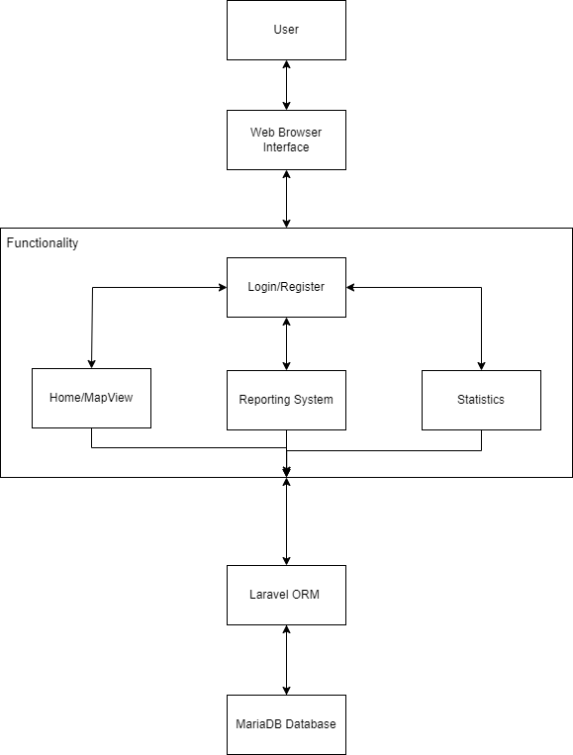

Figure 1 The System Architecture

### Web Browser Interface

This high-level component refers to the user interface (facilitated by the web browser) through which the user would interact with the application. The user interface includes buttons, tabs, text, text boxes, and dropdown menus. The interface would also facilitate the input of images and GPS location by interacting with the device hardware.

### Login and Signup

The login and signup component of the system architecture allows the user to register and log in to the application. On registration, the user is assigned organisations based on their email domain, with the recognised domains summarised in the table below (Table 1).

The registration system assigns admin roles based on the work email domain, with other email domains receiving the “Public” user role.

Table 1 The Organisation Assignments based on the Email Domains

|  |  |  |
| --- | --- | --- |
| Email Domain | Organisation Assigned | Organisation ID |
| @ttec.co.tt | TTEC | 1 |
| @wasa.gov.tt | WASA | 2 |
| @tstt.co.tt | TSTT | 3 |
| Other domains | Public | 5 |

### Home

This component refers to the Home screen, and the landing page of the application following a successful login by the user. This screen presents a map view showing markers of all reports made.

### My Reports

This component allows users to view a list of reports they have submitted to the system. Additionally, each entry has a link to a webpage containing the full details of the report, from which admin users can change the status, or manually delete reports made to their respective company.

### Statistics

The Statistics component allows the admin users to view and generate statistical reports of the fault data reported to their utility company. This module is also responsible for the automated export of report data as email attachments to the respective companies. These attachments are of the XLS format and are sent in predetermined periods: weekly, fortnightly, monthly, and yearly. Each export contains relevant report data for that period.

### My Profile

This module allows the user to manage their account information such as name, email address, and phone number.

## Decomposition Description

### Web Browser Interface

This module is the interface that links all modules and allows the user to interact with the system.

### Registration and Login Module

The Login module consists of two subsystem blocks, illustrating the function of the module (Figure 2). This module allows users to register and login and is responsible for assigning the user organization ID based on the registered email.

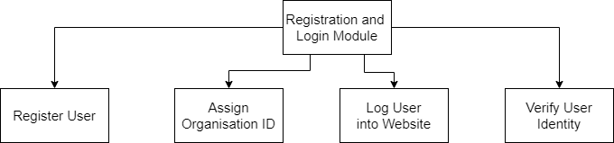

Figure 2 The Login Module Deccomposition

### Home

The Home module is the landing page of the website. It contains the map with markers represented reports submitted to service providers. This is the main landing page and navigation hub of the website.

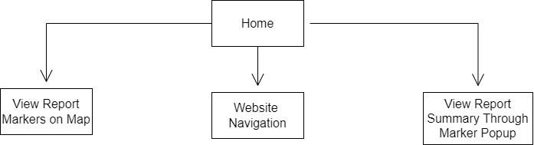

Figure 3 The Home Module Decomposition

### My Reports

This module has different functionalities depending on the type of user. The figure below shows what the module achieves for a user with the “General” role. It allows the user to view the reports made by them as well as the status of the reports made.

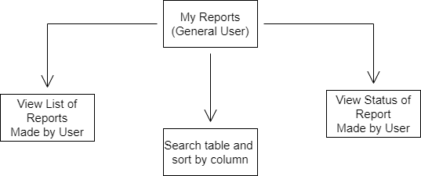

Figure 4 My Reports Module (General User) Decomposition

The admin features of this module are shown below. This module facilitates the management of user reports made to the utility companies.

Each admin user would only be able to perform the functions described in the figure on reports that match their parent company, i.e, the TTEC admins can only modify TTEC reports.

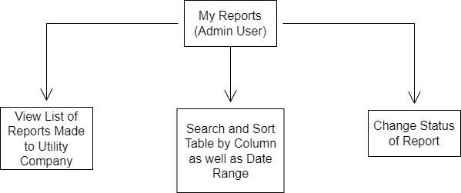

Figure 5 My Reports Module (SP User) Decomposition

### Reporting System

This module is responsible for handing the report lifecycle and process flow (Figure 9). This is the core feature of the reporting application.

### Statistics

The statistics module allows admin users to receive generated statistical reports on a weekly, fortnightly, monthly, and yearly basis. Additionally, this module allows for the viewing of cumulative statistical metrics.

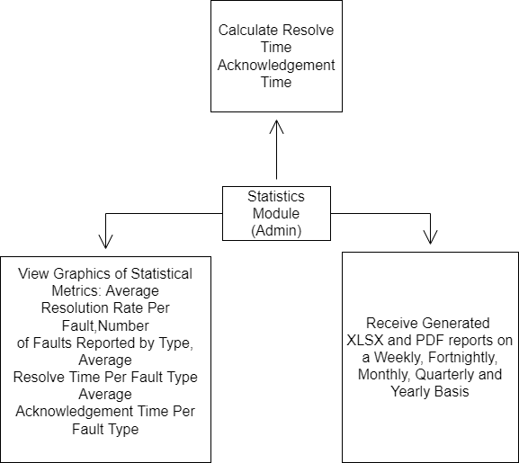

Figure 6 Statistics Module Decomposition

Table 2 Metrics in the Statistics Module

|  |  |
| --- | --- |
| Metric | Description |
| Average Resolution Rate Per Fault | This shows the average resolution rates per fault type. |
| Number of Faults Reported by Type | This shows the number of reported faults by fault type. |
| Average Resolve Time Per Fault Type | This shows the average resolve time by fault type. This metric is calculated from when a report status is changed from “Submitted” to “Completed”. |
| Average Acknowledgement Time Per Fault Type | This metric is calculated from when a report status is changed from “Submitted” to “In-Progress”. |

# Data Design

## Data Description

The system consisted of 10 entities. The purpose of each entity is in Table 2.

Table 3 Entity and Purpose

|  |  |
| --- | --- |
| Entity | Purpose |
| Users | Logs the user information. |
| User_Strikes | Logs the strike count of a particular user. |
| User_Codes | Logs the user-specific generated verification codes to be sent over SMS. |
| Organisations | Master entity containing the domains of registered organisations. Used in assigning an organization ID to users upon registration. |
| Faults | Logs the fault types for each organization. |
| Reports | Logs the report information. |
| Report_Statuses | Logs the times that the report status is changed. |
| Report_Votes | Logs the users and reports voting activity and values. |
| Report_Flags | Logs the users and reports flagging activity and values. |
| Photos | Stores the information for images attached to reports. |

## Data Model

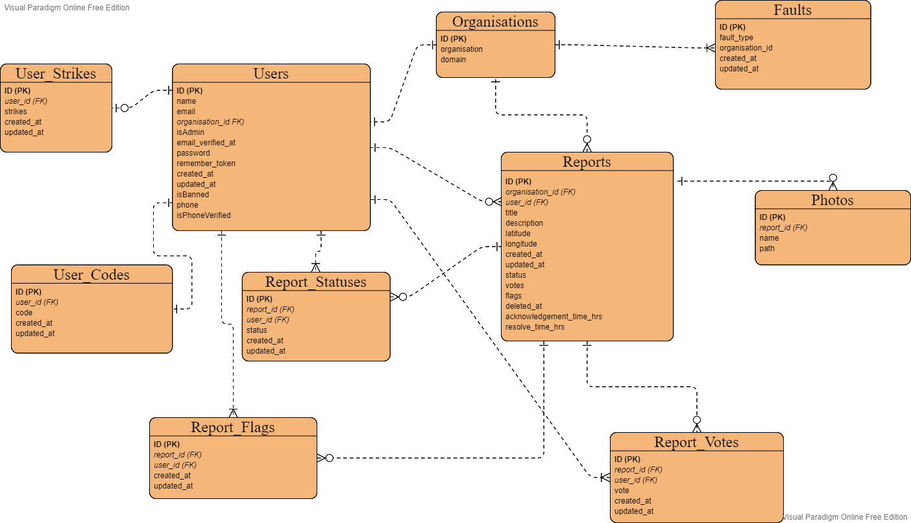

Figure 7 The Entity-Relation Diagram

## Data Dictionary

Table 4 Data Dictionary for the Entities

|  |  |  |  |  |  |
| --- | --- | --- | --- | --- | --- |
| Entity | Attribute | Type | Description | Default | Example |
| Users | user_id | Integer | This is the primary key of the entity | NULL | 1 |
|  | Name | String | Name of the user | NULL | John Doe |
|  | Email | string | This is the email address of the user. Must be unique | NULL | mail@mail.com |
|  | Phone | String | Phone number of the user. Must be unique | NULL | 8681234567 |
|  | isPhoneVerified | Boolean | Indicates if phone is verified (1 or true) or not (0 or false) | 0 | 0 |
|  | isAdmin | Boolean | Indicates if the user is an admin | 0 | 1 |
|  | Email_verified_at | Timestamp | Default Laravel column. Null if email is not verified | NULL | NULL |
|  | isBanned | Boolean | Determines user ban status | 0 | 1 |
|  | Organization_id | Integer | Foreign key relating user to their organisation. Set to 5 for the general public/user | 5 | 5 |
| Organisations | Organization_id | Integer | Primary key for this entity. Each ID represents and organisation | NULL | 1 |
|  | Name | String | Name of the org | NULL | Trinidad and Tobago Electricity Commission |
|  | Domain | String | The email domain of the organization | NULL | Ttec.co.tt |
| Reports | Report_id | Integer | Primary key | NULL | 5 |
|  | Title | String | Title of the report | NULL | Broken Pole |
|  | Description | String | User-entered text to describe the incident | NULL | There is a broken pole |
|  | Latitude | Double | Latitude of entered by the user | NULL | 10.30216412 |
|  | Longitude | Double | Longitude entered by the user | NULL | -61.15837271 |
|  | Votes | Int | Current vote count of the report | 0 | 12 |
|  | Flags | Int | Current count of the flags on a report | 0 | 1 |
|  | Status | String | Describes the status of the report made by the user such as “created”, “submitted”, “in-progress” or “completed”. | Created | Created |
|  | User_id | Integer | Foreign key relating the report to the user. | NULL | 1 |
|  | Report_id | Integer | Foreign key relating the report to an organization. This key is used for controlling which tenant sees the data. | NULL | 2 |
| Report_Votes | Vote_id | Integer | Primary key | NULL | 1 |
|  | User_id | Integer | Foreign key relating user to the vote | NULL | 2 |
|  | Report_id | Integer | Foreign key relating vote to report | NULL | 1 |
|  | Vote | Integer | Value that is either 1, -1, or 0 This increments the "vote” field on the Reports entity | 0 | 1 |
| Report_Flags | Flag_id | Integer | Primary key | NULL | 1 |
|  | User_id | Integer | Foreign key relating user to the flag | NULL | 2 |
|  | Report_id | Integer | Foreign key relating flag to report | NULL | 1 |
|  | Flag | Integer | Value that is either 1, -1, or 0 This increments the "flag” field on the Reports entity | 0 | 1 |
| Report_Statuses | Status_id | Integer | Primary Key | NULL | 1 |
|  | Status | String | Describes the status of the report made by the user such as “created”, “submitted”, “in-progress” or “completed”. | Created | In-Progress |
|  | Report_id | Integer | Foreign key relating report to the status | NULL | 1 |
|  | User_id | Integer | Foreign key relating report to the user that manually changed the status | NULL | 1 |
|  | Created_at | Timestamps | Time the record was created | NULL | 2022-03-10 08:41:54 |
|  | Updated_at | Timestamps | Time the record was updated | NULL | 2022-03-10 08:41:54 |
| Photos | Photo_id | Integer | Primary key | NULL | 1 |
|  | Name | String | Name of the image | NULL | Image.jpg |
|  | Path | String | The image storage path | NULL | /public/images |
|  | Report_id | Integer | Foreign key relating the photo to the report | NULL | 1 |
| Faults | Fault_id | Integer | Primary key | NULL | 1 |
|  | Fault_type | String | The type of fault | NULL | Street light |
|  | Organization_id | Integer | Foreign key relating the faults to the organization | NULL | 1 |
| User_Codes | User_code_id | Integer | Primary key | NULL | 1 |
|  | User_id | Integer | Foreign key relating table to users entity | NULL | 1 |
|  | Code | Integer | Generated code for SMS verification | NULL | 8008 |
| User_strikes | User_strike_id | Integer | Primary key | NULL | 1 |
|  | User_id | Integer | Foreign key linking the strikes to the users | NULL | 2 |
|  | Strikes | Integer | Contains the value of the number of strikes that a user has | 0 | 2 |

# Component Design

## Register/Login Module

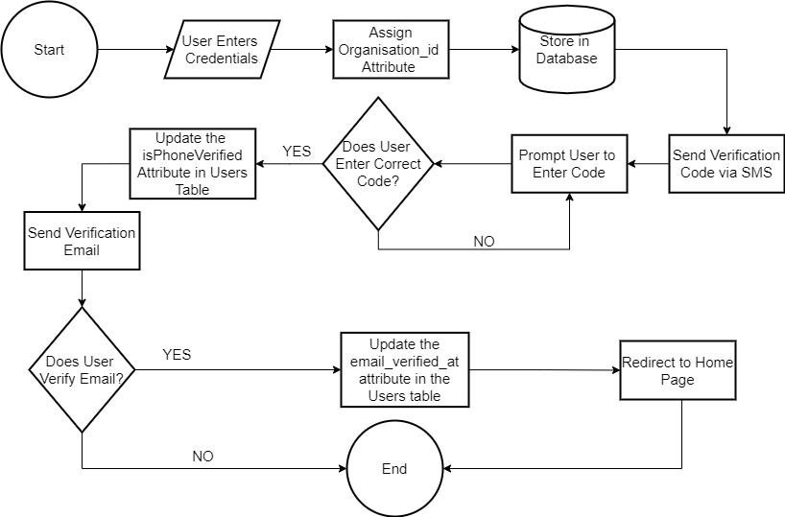

Figure 8 Component Design of the Register/Login Module

## Reporting System Module

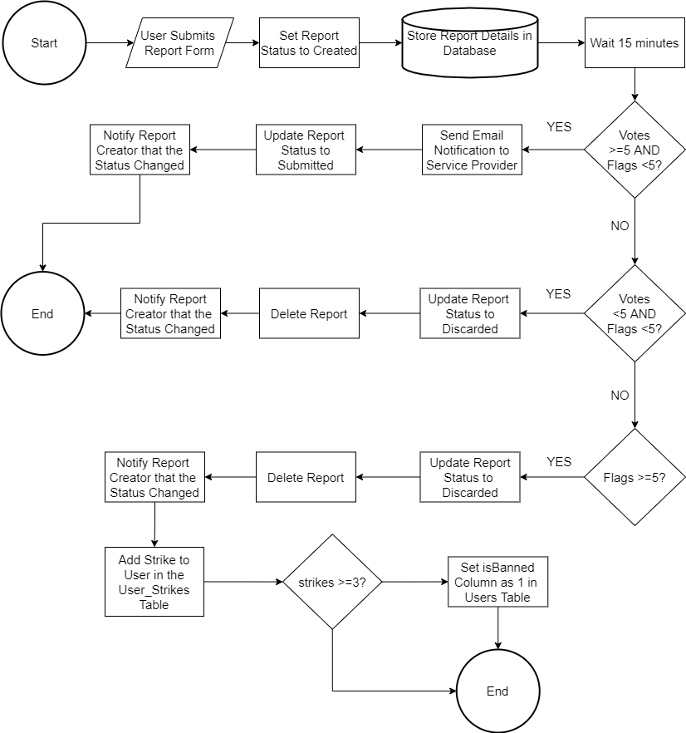

Figure 9 The Reporting System Module-Process Breakdown

## My Profile

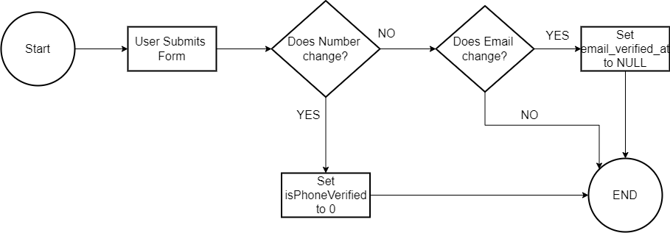

Figure 10 Process Diagram for the My Profile Page